(Approx. 809 words)

Use Speech to Control Your PC and Compose Text
By Nancy DeMarte, 2nd Vice President, Sarasota Technology Users Group, FL
October 2017 issue, STUG Monitor
www.spcug.org
ndemarte (at) Verizon.net

Speak:
Many modern devices have digital voice personalities that can help you find things or complete tasks. Some of these even have names, like Siri for Apple devices, Alexa for Amazon Echo, and Cortana for Windows. Microsoft Office and Windows 10 recently have added or upgraded speech features that provide both text to speech and speech to text. Speak is a new feature that helps you proofread what you have typed by listening to the computer read it aloud.

For example, if I’m typing a Word document and want to see if my wording is smooth and accurate, I can use “Speak” to hear how it sounds. The Speak feature is also found in other Microsoft apps - Outlook, PowerPoint, and OneNote.
Speak icon


To use ‘Speak,’ click anywhere in a document. Then click the Review tab on the ribbon. In the Speech group, click ‘Read Aloud,’ which opens an audio control bar. Click the right-pointing single arrow, then sit back and listen. You can choose a male or female voice by clicking the setting icon which resembles a person on the audio bar.
Audio Control bar

Windows Speech Recognition (WSR):
Windows has had a speech recognition feature for several years. This tool lets a user dictate into a microphone without the use of a keyboard or mouse and have his or her speech translated into text. It can be used to compose articles, write letters or emails, fill out forms, or complete other writing tasks. You can also use WSR to perform the basic functions of a computer, like opening an app, selecting a word, showing a list of commands, and adding punctuation. Originally, it was difficult to set up, but the current version is much , o configure and use. Learning to use WSR is especially worthwhile if your typing skills are weak.

You must have a microphone before setting up Speech Recognition. I found that a set of headphones with a microphone attached works very well. While it is also possible to find a Windows microphone in the MS store, a headset or free-standing mic is recommended.

Once you have a microphone plugged into your computer and turned on, it’s time to locate and set up Speech Recognition. In Windows 7, click Start > All Programs > Accessories > Ease of Access > Speech Recognition. In Win 10, type ‘Speech’ in the Search box and choose the best match, Speech Recognition, which opens the Speech Configuration window, pictured below:

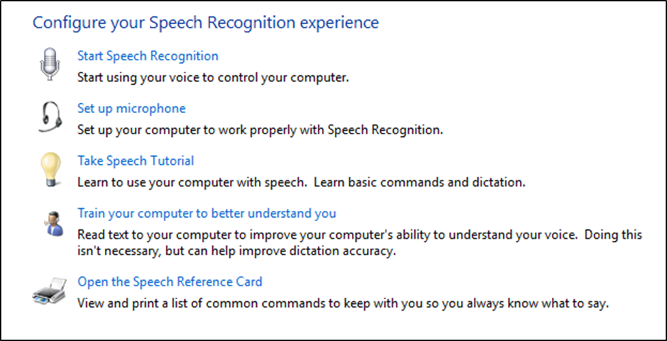
Speech Configuration Window

- There is a wizard (set of steps) to help you with setup. Click “Start Speech Recognition” to start the wizard. It will take you through all the steps in the order in which they are listed.
- First, you will set up the microphone for correct placement and volume setting.
- The speech tutorial consists of two short video tutorials that demonstrate the two main uses for speech recognition: “How to use WSR to get around your computer” and “How to use dictation with WSR”. These are worth watching more than once.
- In “Train your computer,” you practice reading text aloud so that WSR can learn your vocal inflections, accent, and tone. This makes the transition from speech to text more accurate.
- The last step is to print a few pages of valuable commands that WSR recognizes, a handy list.

While no speech recognition tool is perfect, the Windows version does a pretty good job, and setup is an easy, non-threatening process.

